# Laboratory 3

Title of the Laboratory Exercise: data model to relational model

1. Introduction and Purpose of Experiment

The ER schema is to be converted into a relational schema as data cannot be stored in an ER schema. A relation schema gives the basic information describing a table or relation. It is the logical definition of a table. This includes a set of column names, and the data types associated with each column. By doing this lab, students will be able to map ER schema to relational schema.

1. Aim and Objectives

Aim

* To map data model to relational model

Objectives

At the end of this lab, the student will be able to

* Map ER schema to relational schema
* Insert tuples using SQL commands for the developed database schema

1. Experimental Procedure
   * 1. Map all the components in the ER diagram to corresponding relation entities and instances
     2. Insert tuples using SQL commands
     3. Design SQL commands using aggregate functions in SQL
     4. Execute SQL commands
     5. Test the executed commands
     6. Document the Results
     7. Analyse and discuss the outcomes of your experiment
2. Questions
3. Consider the ER diagram you have drawn in Laboratory 2. Convert the ER diagram to corresponding relational database schema.
4. Insert the tuples (minimum five) for the developed database schema using SQL commands. Perform aggregate functions in SQL based on the developed database schema.
5. Calculations/Computations/Algorithms

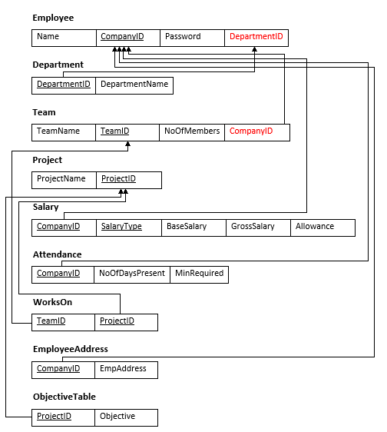

Figure Final Relational Schema

1. Presentation of Results

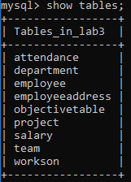

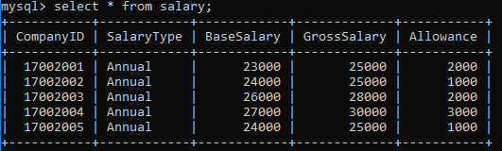

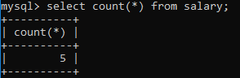

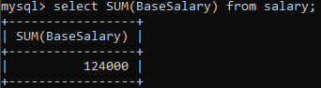

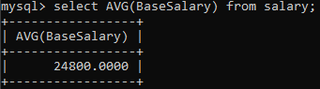

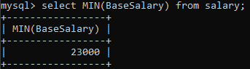

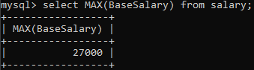

1. Conclusions

A set of attributes is called a relation schema (or relation scheme). A relation schema is also known as table schema (or table scheme). A relation schema can be thought of as the basic [information](http://ecomputernotes.com/fundamental/information-technology/what-do-you-mean-by-data-and-information) describing a table or relation. It is the logical definition of a table. Relation schema defines what the name of the table is. This includes a set of column names, the [data type](http://ecomputernotes.com/java/data-type-variable-and-array/explain-data-types-in-java)s associated with each column.

A database schema is the collection of relation schemas for a whole database. Relational or Database schema is a collection of meta-data. Database schema describes the structure and constraints of data representing in a particular domain. A Relational schema can be described a blueprint of a database that outlines the way data is organized into tables. This blueprint will not contain any type of data. In a relational schema, each tuple is divided into fields called Domains.

There are different kinds of database schemas:

* Conceptual schema
* Logical schema
* Physical schema

1. Comments

1. Limitations of Experiments

* In entity-relationship modelling, explicit object types are specified. In the relational model, these may survive only as names of relations. In the relational model, entities have no independent identification or existence.
* The schema of all records in a table must be the same. If you've encountered tables with many empty columns for optional fields, it's a result of this rigidity. Tables with many empty columns waste a lot of space.

2. Learning happened

We learnt about relational database schema, how to map ER diagram to relational schema.

3. Recommendations

* The specific real-[world](https://www.toppr.com/guides/general-knowledge/world-organisations-and-diversities/world-organisations/) concept that appears more than once in a relationship should be represented by different names.
* The integrity constraints that are specified on database schema shall apply to every database state of that schema.